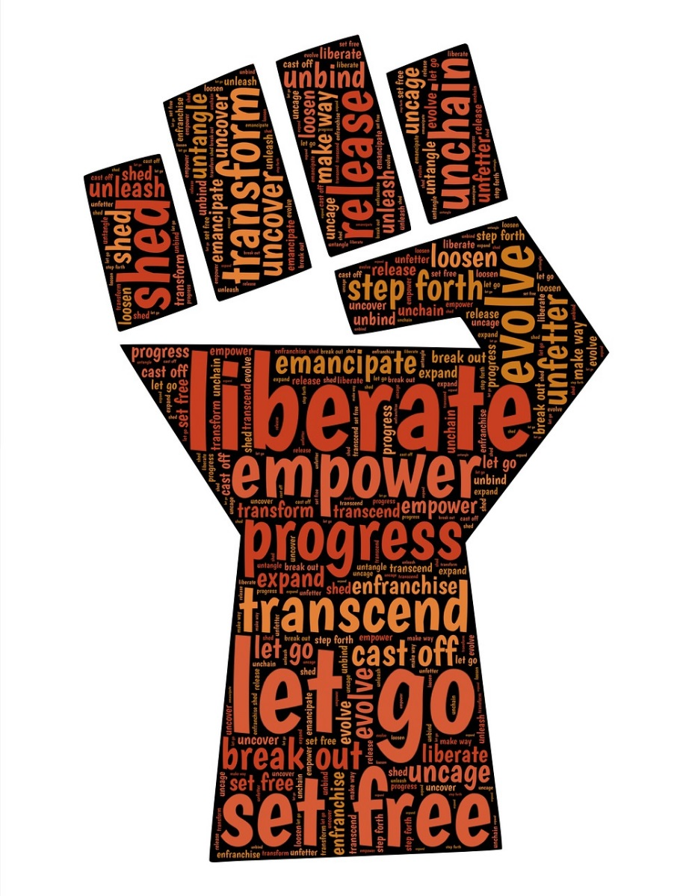
Student of Color Support and Empowerment Group
This is a support group for students of color who are often navigating a complex and difficult college environment. The focus of this group is on creating a space for students of color to connect over experiences of discrimination/oppression/racism, support one another, and gain wisdom and energy from each other. Topics covered in the group will vary based on the members' preferences, but some examples include but are not limited to: microaggressions, pressure to prove yourself, feeling like you don't fit in, discrimination, first-generation college student, family issues, and academic issues/concerns, romantic relationships, sexism, racism, imposter syndrome, stereotype threat, self-awareness, self-esteem, emotional health issues and other stressors related to being a person of color in this university environment.

If interested, please contact Dr. Andrea Salazar-Nuñez at salazar6@uw.edu or (206) 543-1240 for more information. Group meets Wednesdays from 3-4pm at the UW Counseling Center, 401 Schmitz Hall

